Министерство науки и высшего образования Российской Федерации   
Федеральное государственное бюджетное образовательное   
учреждение высшего образования   
«Алтайский государственный технический   
университет им. И.И. Ползунова»

Факультет информационных технологий

Кафедра прикладной математики

Отчёт защищён с оценкой__________________

Преподаватель Ананьев П.И.

«_____»__________________2022 г.

Отчёт

по лабораторной работе № 2

«Построение реляционной модели с использованием CASE-средств»

по дисциплине «Курсовая работа по базам данных»

Студенты группы ПИ-91 Гулин А.Н., Шинтяпин И.И., Шульпов В.М.

Преподаватель доцент Ананьев П.И.

Барнаул 2022

**Задание**

Используя концептуальную модель, построить логическую модель в технологии IDEF1X. Предусмотреть поддержание ссылочной целостности. На основании логической модели разработать физическую модель для выбранной СУБД.

**Вариант 2.** Система управления поточно-массовым производством (на примере производства автомобилей).

**Выполнение работы**

**Логическая модель**

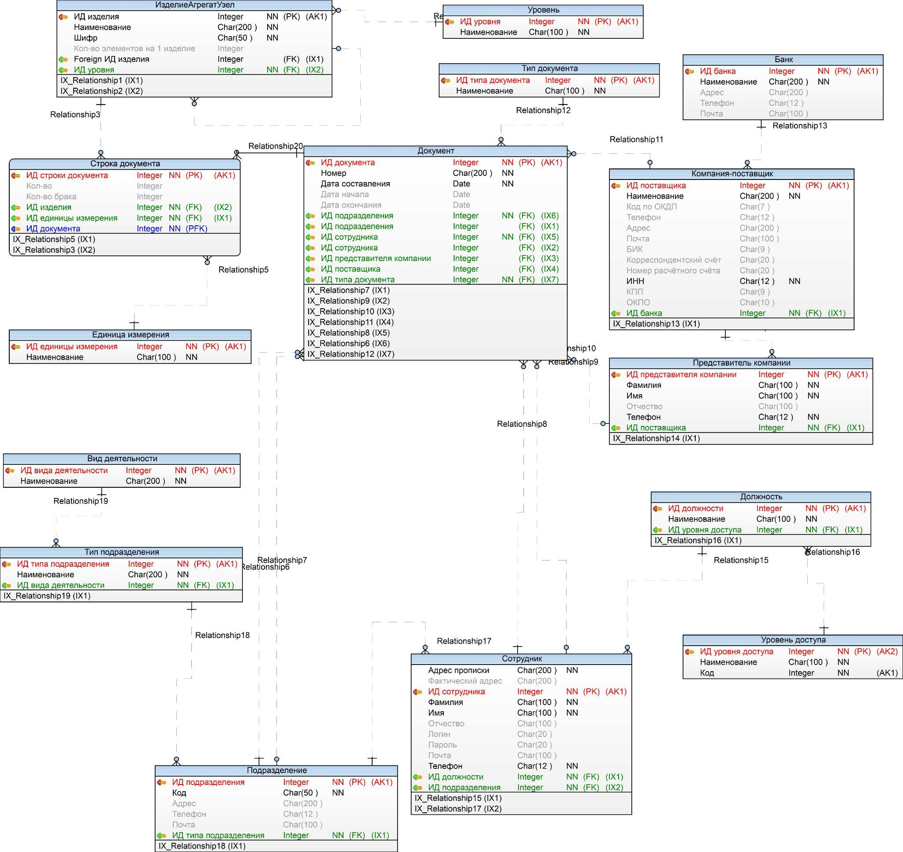

**Физическая модель**

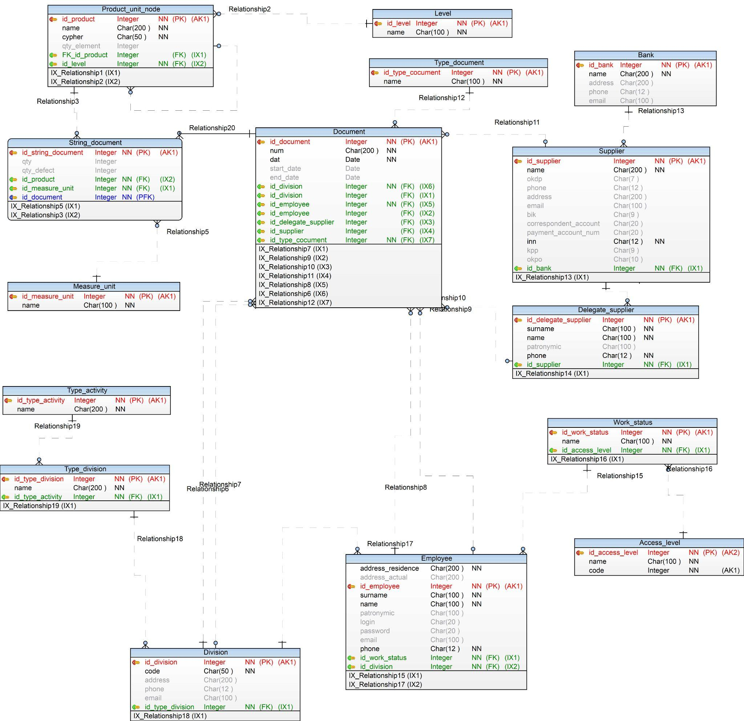

**Скрипт для генерации БД**

/*

Created: 11.10.2022

Modified: 14.10.2022

Model: Car_manufacturing

Database: Oracle 19c

*/

-- Create tables section -------------------------------------------------

-- Table Product_unit_node

**CREATE** **TABLE** "Product_unit_node"**(**

"id_product" Integer GENERATED ALWAYS **AS** **IDENTITY(**

**START** **WITH** 1

**INCREMENT** **BY** 1

NOMAXVALUE

NOMINVALUE

NOCACHE**)** **NOT** **NULL,**

"name" Char**(**200 **)** **NOT** **NULL,**

"cypher" Char**(**50 **)** **NOT** **NULL,**

"qty_element" Integer**,**

"FK_id_product" Integer**,**

"id_level" Integer

**)**

**/**

-- Create indexes for table Product_unit_node

**CREATE** **INDEX** "IX_Relationship1" **ON** "Product_unit_node" **(**"FK_id_product"**)**

**/**

**CREATE** **INDEX** "IX_Relationship21" **ON** "Product_unit_node" **(**"id_level"**)**

**/**

-- Add keys for table Product_unit_node

**ALTER** **TABLE** "Product_unit_node" **ADD** **CONSTRAINT** "PK_Product_unit_node" **PRIMARY** **KEY** **(**"id_product"**)**

**/**

**ALTER** **TABLE** "Product_unit_node" **ADD** **CONSTRAINT** "ИД изделия" **UNIQUE** **(**"id_product"**)**

**/**

-- Table String_document

**CREATE** **TABLE** "String_document"**(**

"id_string_document" Integer GENERATED ALWAYS **AS** **IDENTITY(**

**START** **WITH** 1

**INCREMENT** **BY** 1

NOMAXVALUE

NOMINVALUE

NOCACHE**)** **NOT** **NULL,**

"qty" Integer**,**

"qty_defect" Integer**,**

"id_product" Integer **NOT** **NULL,**

"id_measure_unit" Integer **NOT** **NULL,**

"id_document" Integer **NOT** **NULL**

**)**

**/**

-- Create indexes for table String_document

**CREATE** **INDEX** "IX_Relationship5" **ON** "String_document" **(**"id_measure_unit"**)**

**/**

**CREATE** **INDEX** "IX_Relationship3" **ON** "String_document" **(**"id_product"**)**

**/**

-- Add keys for table String_document

**ALTER** **TABLE** "String_document" **ADD** **CONSTRAINT** "PK_String_document" **PRIMARY** **KEY** **(**"id_string_document"**,**"id_document"**)**

**/**

**ALTER** **TABLE** "String_document" **ADD** **CONSTRAINT** "ИД строки документа" **UNIQUE** **(**"id_string_document"**)**

**/**

-- Table Measure_unit

**CREATE** **TABLE** "Measure_unit"**(**

"id_measure_unit" Integer GENERATED ALWAYS **AS** **IDENTITY(**

**START** **WITH** 1

**INCREMENT** **BY** 1

NOMAXVALUE

NOMINVALUE

NOCACHE**)** **NOT** **NULL,**

"name" Char**(**100 **)** **NOT** **NULL**

**)**

**/**

-- Add keys for table Measure_unit

**ALTER** **TABLE** "Measure_unit" **ADD** **CONSTRAINT** "PK_Measure_unit" **PRIMARY** **KEY** **(**"id_measure_unit"**)**

**/**

**ALTER** **TABLE** "Measure_unit" **ADD** **CONSTRAINT** "ИД единицы измерения" **UNIQUE** **(**"id_measure_unit"**)**

**/**

-- Table Document

**CREATE** **TABLE** "Document"**(**

"id_document" Integer GENERATED ALWAYS **AS** **IDENTITY(**

**START** **WITH** 1

**INCREMENT** **BY** 1

NOMAXVALUE

NOMINVALUE

NOCACHE**)** **NOT** **NULL,**

"num" Char**(**200 **)** **NOT** **NULL,**

"dat" Date **NOT** **NULL,**

"start_date" Date**,**

"end_date" Date**,**

"id_division_sender" Integer **NOT** **NULL,**

"id_division_reciever" Integer**,**

"id_employee_sender" Integer **NOT** **NULL,**

"id_employee_reciever" Integer**,**

"id_delegate_supplier" Integer**,**

"id_supplier" Integer**,**

"id_type_cocument" Integer **NOT** **NULL**

**)**

**/**

-- Create indexes for table Document

**CREATE** **INDEX** "IX_Relationship7" **ON** "Document" **(**"id_division_reciever"**)**

**/**

**CREATE** **INDEX** "IX_Relationship9" **ON** "Document" **(**"id_employee_reciever"**)**

**/**

**CREATE** **INDEX** "IX_Relationship10" **ON** "Document" **(**"id_delegate_supplier"**)**

**/**

**CREATE** **INDEX** "IX_Relationship11" **ON** "Document" **(**"id_supplier"**)**

**/**

**CREATE** **INDEX** "IX_Relationship8" **ON** "Document" **(**"id_employee_sender"**)**

**/**

**CREATE** **INDEX** "IX_Relationship6" **ON** "Document" **(**"id_division_sender"**)**

**/**

**CREATE** **INDEX** "IX_Relationship12" **ON** "Document" **(**"id_type_cocument"**)**

**/**

-- Add keys for table Document

**ALTER** **TABLE** "Document" **ADD** **CONSTRAINT** "PK_Document" **PRIMARY** **KEY** **(**"id_document"**)**

**/**

**ALTER** **TABLE** "Document" **ADD** **CONSTRAINT** "ИД документа" **UNIQUE** **(**"id_document"**)**

**/**

-- Table Type_document

**CREATE** **TABLE** "Type_document"**(**

"id_type_cocument" Integer GENERATED ALWAYS **AS** **IDENTITY(**

**START** **WITH** 1

**INCREMENT** **BY** 1

NOMAXVALUE

NOMINVALUE

NOCACHE**)** **NOT** **NULL,**

"name" Char**(**100 **)** **NOT** **NULL**

**)**

**/**

-- Add keys for table Type_document

**ALTER** **TABLE** "Type_document" **ADD** **CONSTRAINT** "PK_Type_document" **PRIMARY** **KEY** **(**"id_type_cocument"**)**

**/**

**ALTER** **TABLE** "Type_document" **ADD** **CONSTRAINT** "ИД типа документа" **UNIQUE** **(**"id_type_cocument"**)**

**/**

-- Table Employee

**CREATE** **TABLE** "Employee"**(**

"address_residence" Char**(**200 **)** **NOT** **NULL,**

"address_actual" Char**(**200 **),**

"id_employee" Integer GENERATED ALWAYS **AS** **IDENTITY(**

**START** **WITH** 1

**INCREMENT** **BY** 1

NOMAXVALUE

NOMINVALUE

NOCACHE**)** **NOT** **NULL,**

"surname" Char**(**100 **)** **NOT** **NULL,**

"name" Char**(**100 **)** **NOT** **NULL,**

"patronymic" Char**(**100 **),**

"login" Char**(**20 **),**

"password" Char**(**20 **),**

"email" Char**(**100 **),**

"phone" Char**(**12 **)** **NOT** **NULL,**

"id_work_status" Integer **NOT** **NULL,**

"id_division" Integer **NOT** **NULL**

**)**

**/**

-- Create indexes for table Employee

**CREATE** **INDEX** "IX_Relationship15" **ON** "Employee" **(**"id_work_status"**)**

**/**

**CREATE** **INDEX** "IX_Relationship17" **ON** "Employee" **(**"id_division"**)**

**/**

-- Add keys for table Employee

**ALTER** **TABLE** "Employee" **ADD** **CONSTRAINT** "PK_Employee" **PRIMARY** **KEY** **(**"id_employee"**)**

**/**

**ALTER** **TABLE** "Employee" **ADD** **CONSTRAINT** "ИД сотрудника" **UNIQUE** **(**"id_employee"**)**

**/**

-- Table Work_status

**CREATE** **TABLE** "Work_status"**(**

"id_work_status" Integer GENERATED ALWAYS **AS** **IDENTITY(**

**START** **WITH** 1

**INCREMENT** **BY** 1

NOMAXVALUE

NOMINVALUE

NOCACHE**)** **NOT** **NULL,**

"name" Char**(**100 **)** **NOT** **NULL,**

"id_access_level" Integer **NOT** **NULL**

**)**

**/**

-- Create indexes for table Work_status

**CREATE** **INDEX** "IX_Relationship16" **ON** "Work_status" **(**"id_access_level"**)**

**/**

-- Add keys for table Work_status

**ALTER** **TABLE** "Work_status" **ADD** **CONSTRAINT** "PK_Work_status" **PRIMARY** **KEY** **(**"id_work_status"**)**

**/**

**ALTER** **TABLE** "Work_status" **ADD** **CONSTRAINT** "ИД должности" **UNIQUE** **(**"id_work_status"**)**

**/**

-- Table Access_level

**CREATE** **TABLE** "Access_level"**(**

"id_access_level" Integer GENERATED ALWAYS **AS** **IDENTITY(**

**START** **WITH** 1

**INCREMENT** **BY** 1

NOMAXVALUE

NOMINVALUE

NOCACHE**)** **NOT** **NULL,**

"name" Char**(**100 **)** **NOT** **NULL,**

"code" Integer **NOT** **NULL**

**)**

**/**

-- Add keys for table Access_level

**ALTER** **TABLE** "Access_level" **ADD** **CONSTRAINT** "PK_Access_level" **PRIMARY** **KEY** **(**"id_access_level"**)**

**/**

**ALTER** **TABLE** "Access_level" **ADD** **CONSTRAINT** "Код" **UNIQUE** **(**"code"**)**

**/**

**ALTER** **TABLE** "Access_level" **ADD** **CONSTRAINT** "ИД уровня доступа" **UNIQUE** **(**"id_access_level"**)**

**/**

-- Table Division

**CREATE** **TABLE** "Division"**(**

"id_division" Integer GENERATED ALWAYS **AS** **IDENTITY(**

**START** **WITH** 1

**INCREMENT** **BY** 1

NOMAXVALUE

NOMINVALUE

NOCACHE**)** **NOT** **NULL,**

"code" Char**(**50 **)** **NOT** **NULL,**

"address" Char**(**200 **),**

"phone" Char**(**12 **),**

"email" Char**(**100 **),**

"id_type_division" Integer **NOT** **NULL**

**)**

**/**

-- Create indexes for table Division

**CREATE** **INDEX** "IX_Relationship18" **ON** "Division" **(**"id_type_division"**)**

**/**

-- Add keys for table Division

**ALTER** **TABLE** "Division" **ADD** **CONSTRAINT** "PK_Division" **PRIMARY** **KEY** **(**"id_division"**)**

**/**

**ALTER** **TABLE** "Division" **ADD** **CONSTRAINT** "ИД подразделения" **UNIQUE** **(**"id_division"**)**

**/**

-- Table Type_division

**CREATE** **TABLE** "Type_division"**(**

"id_type_division" Integer GENERATED ALWAYS **AS** **IDENTITY(**

**START** **WITH** 1

**INCREMENT** **BY** 1

NOMAXVALUE

NOMINVALUE

NOCACHE**)** **NOT** **NULL,**

"name" Char**(**200 **)** **NOT** **NULL,**

"id_type_activity" Integer **NOT** **NULL**

**)**

**/**

-- Create indexes for table Type_division

**CREATE** **INDEX** "IX_Relationship19" **ON** "Type_division" **(**"id_type_activity"**)**

**/**

-- Add keys for table Type_division

**ALTER** **TABLE** "Type_division" **ADD** **CONSTRAINT** "PK_Type_division" **PRIMARY** **KEY** **(**"id_type_division"**)**

**/**

**ALTER** **TABLE** "Type_division" **ADD** **CONSTRAINT** "ИД типа подразделения" **UNIQUE** **(**"id_type_division"**)**

**/**

-- Table Type_activity

**CREATE** **TABLE** "Type_activity"**(**

"id_type_activity" Integer GENERATED ALWAYS **AS** **IDENTITY(**

**START** **WITH** 1

**INCREMENT** **BY** 1

NOMAXVALUE

NOMINVALUE

NOCACHE**)** **NOT** **NULL,**

"name" Char**(**200 **)** **NOT** **NULL**

**)**

**/**

-- Add keys for table Type_activity

**ALTER** **TABLE** "Type_activity" **ADD** **CONSTRAINT** "PK_Type_activity" **PRIMARY** **KEY** **(**"id_type_activity"**)**

**/**

**ALTER** **TABLE** "Type_activity" **ADD** **CONSTRAINT** "ИД вида деятельности" **UNIQUE** **(**"id_type_activity"**)**

**/**

-- Table Supplier

**CREATE** **TABLE** "Supplier"**(**

"id_supplier" Integer GENERATED ALWAYS **AS** **IDENTITY(**

**START** **WITH** 1

**INCREMENT** **BY** 1

NOMAXVALUE

NOMINVALUE

NOCACHE**)** **NOT** **NULL,**

"name" Char**(**200 **)** **NOT** **NULL,**

"okdp" Char**(**7 **),**

"phone" Char**(**12 **),**

"address" Char**(**200 **),**

"email" Char**(**100 **),**

"bik" Char**(**9 **),**

"correspondent_account" Char**(**20 **),**

"payment_account_num" Char**(**20 **),**

"inn" Char**(**12 **)** **NOT** **NULL,**

"kpp" Char**(**9 **),**

"okpo" Char**(**10 **),**

"id_bank" Integer **NOT** **NULL**

**)**

**/**

-- Create indexes for table Supplier

**CREATE** **INDEX** "IX_Relationship13" **ON** "Supplier" **(**"id_bank"**)**

**/**

-- Add keys for table Supplier

**ALTER** **TABLE** "Supplier" **ADD** **CONSTRAINT** "PK_Supplier" **PRIMARY** **KEY** **(**"id_supplier"**)**

**/**

**ALTER** **TABLE** "Supplier" **ADD** **CONSTRAINT** "ИД поставщика" **UNIQUE** **(**"id_supplier"**)**

**/**

-- Table Bank

**CREATE** **TABLE** "Bank"**(**

"id_bank" Integer GENERATED ALWAYS **AS** **IDENTITY(**

**START** **WITH** 1

**INCREMENT** **BY** 1

NOMAXVALUE

NOMINVALUE

NOCACHE**)** **NOT** **NULL,**

"name" Char**(**200 **)** **NOT** **NULL,**

"address" Char**(**200 **),**

"phone" Char**(**12 **),**

"email" Char**(**100 **)**

**)**

**/**

-- Add keys for table Bank

**ALTER** **TABLE** "Bank" **ADD** **CONSTRAINT** "PK_Bank" **PRIMARY** **KEY** **(**"id_bank"**)**

**/**

**ALTER** **TABLE** "Bank" **ADD** **CONSTRAINT** "ИД банка" **UNIQUE** **(**"id_bank"**)**

**/**

-- Table Delegate_supplier

**CREATE** **TABLE** "Delegate_supplier"**(**

"id_delegate_supplier" Integer GENERATED ALWAYS **AS** **IDENTITY(**

**START** **WITH** 1

**INCREMENT** **BY** 1

NOMAXVALUE

NOMINVALUE

NOCACHE**)** **NOT** **NULL,**

"surname" Char**(**100 **)** **NOT** **NULL,**

"name" Char**(**100 **)** **NOT** **NULL,**

"patronymic" Char**(**100 **),**

"phone" Char**(**12 **)** **NOT** **NULL,**

"id_supplier" Integer **NOT** **NULL**

**)**

**/**

-- Create indexes for table Delegate_supplier

**CREATE** **INDEX** "IX_Relationship14" **ON** "Delegate_supplier" **(**"id_supplier"**)**

**/**

-- Add keys for table Delegate_supplier

**ALTER** **TABLE** "Delegate_supplier" **ADD** **CONSTRAINT** "PK_Delegate_supplier" **PRIMARY** **KEY** **(**"id_delegate_supplier"**)**

**/**

**ALTER** **TABLE** "Delegate_supplier" **ADD** **CONSTRAINT** "ИД представителя компании" **UNIQUE** **(**"id_delegate_supplier"**)**

**/**

-- Table Level

**CREATE** **TABLE** "Level"**(**

"id_level" Integer GENERATED ALWAYS **AS** **IDENTITY(**

**START** **WITH** 1

**INCREMENT** **BY** 1

NOMAXVALUE

NOMINVALUE

NOCACHE**)** **NOT** **NULL,**

"name" Char**(**100 **)** **NOT** **NULL**

**)**

**/**

-- Add keys for table Level

**ALTER** **TABLE** "Level" **ADD** **CONSTRAINT** "PK_Level" **PRIMARY** **KEY** **(**"id_level"**)**

**/**

**ALTER** **TABLE** "Level" **ADD** **CONSTRAINT** "ИД уровня" **UNIQUE** **(**"id_level"**)**

**/**

-- Create foreign keys (relationships) section -------------------------------------------------

**ALTER** **TABLE** "Product_unit_node" **ADD** **CONSTRAINT** "Relationship1" **FOREIGN** **KEY** **(**"FK_id_product"**)** **REFERENCES** "Product_unit_node" **(**"id_product"**)**

**/**

**ALTER** **TABLE** "String_document" **ADD** **CONSTRAINT** "Relationship3" **FOREIGN** **KEY** **(**"id_product"**)** **REFERENCES** "Product_unit_node" **(**"id_product"**)**

**/**

**ALTER** **TABLE** "String_document" **ADD** **CONSTRAINT** "Relationship5" **FOREIGN** **KEY** **(**"id_measure_unit"**)** **REFERENCES** "Measure_unit" **(**"id_measure_unit"**)**

**/**

**ALTER** **TABLE** "Document" **ADD** **CONSTRAINT** "Relationship6" **FOREIGN** **KEY** **(**"id_division_sender"**)** **REFERENCES** "Division" **(**"id_division"**)**

**/**

**ALTER** **TABLE** "Document" **ADD** **CONSTRAINT** "Relationship7" **FOREIGN** **KEY** **(**"id_division_reciever"**)** **REFERENCES** "Division" **(**"id_division"**)**

**/**

**ALTER** **TABLE** "Document" **ADD** **CONSTRAINT** "Relationship8" **FOREIGN** **KEY** **(**"id_employee_sender"**)** **REFERENCES** "Employee" **(**"id_employee"**)**

**/**

**ALTER** **TABLE** "Document" **ADD** **CONSTRAINT** "Relationship9" **FOREIGN** **KEY** **(**"id_employee_reciever"**)** **REFERENCES** "Employee" **(**"id_employee"**)**

**/**

**ALTER** **TABLE** "Document" **ADD** **CONSTRAINT** "Relationship10" **FOREIGN** **KEY** **(**"id_delegate_supplier"**)** **REFERENCES** "Delegate_supplier" **(**"id_delegate_supplier"**)**

**/**

**ALTER** **TABLE** "Document" **ADD** **CONSTRAINT** "Relationship11" **FOREIGN** **KEY** **(**"id_supplier"**)** **REFERENCES** "Supplier" **(**"id_supplier"**)**

**/**

**ALTER** **TABLE** "Document" **ADD** **CONSTRAINT** "Relationship12" **FOREIGN** **KEY** **(**"id_type_cocument"**)** **REFERENCES** "Type_document" **(**"id_type_cocument"**)**

**/**

**ALTER** **TABLE** "Supplier" **ADD** **CONSTRAINT** "Relationship13" **FOREIGN** **KEY** **(**"id_bank"**)** **REFERENCES** "Bank" **(**"id_bank"**)**

**/**

**ALTER** **TABLE** "Delegate_supplier" **ADD** **CONSTRAINT** "Relationship14" **FOREIGN** **KEY** **(**"id_supplier"**)** **REFERENCES** "Supplier" **(**"id_supplier"**)**

**/**

**ALTER** **TABLE** "Employee" **ADD** **CONSTRAINT** "Relationship15" **FOREIGN** **KEY** **(**"id_work_status"**)** **REFERENCES** "Work_status" **(**"id_work_status"**)**

**/**

**ALTER** **TABLE** "Work_status" **ADD** **CONSTRAINT** "Relationship16" **FOREIGN** **KEY** **(**"id_access_level"**)** **REFERENCES** "Access_level" **(**"id_access_level"**)**

**/**

**ALTER** **TABLE** "Employee" **ADD** **CONSTRAINT** "Relationship17" **FOREIGN** **KEY** **(**"id_division"**)** **REFERENCES** "Division" **(**"id_division"**)**

**/**

**ALTER** **TABLE** "Division" **ADD** **CONSTRAINT** "Relationship18" **FOREIGN** **KEY** **(**"id_type_division"**)** **REFERENCES** "Type_division" **(**"id_type_division"**)**

**/**

**ALTER** **TABLE** "Type_division" **ADD** **CONSTRAINT** "Relationship19" **FOREIGN** **KEY** **(**"id_type_activity"**)** **REFERENCES** "Type_activity" **(**"id_type_activity"**)**

**/**

**ALTER** **TABLE** "String_document" **ADD** **CONSTRAINT** "Relationship20" **FOREIGN** **KEY** **(**"id_document"**)** **REFERENCES** "Document" **(**"id_document"**)** **ON** **DELETE** **CASCADE**

**/**

**ALTER** **TABLE** "Product_unit_node" **ADD** **CONSTRAINT** "Relationship21" **FOREIGN** **KEY** **(**"id_level"**)** **REFERENCES** "Level" **(**"id_level"**)**

**/**